Commercial offer
OJSC “Plant Minskagroprommash”
____________________________________________________________

OJSC "Plant Minskagroprommash" presents to you electric saws of its own production that are intended for butchering livestock.
Our company has been working for 43 years and it is the only manufacturer of these electric saws in Belarus.
OJSC "Plant Minskagroprommash" offers 3 types of electric saws for cutting carcases: RZ-FRP-2, FEG and bandsaw PRT-1.
The company also produces a wide range of agricultural and municipal equipment: disc, including meliorative harrows, brush, dozer and loading equipment.
The products are manufactured by HS codes:
- 8438 50 000 0 «Electric saws for butchering livestock»;
- 8432 21 000 0 «Disc harrows»;
- 8431 42 000 0 «Dozer equipment»;
- 9603 50 000 9 «Brush equipment».
The complete information about products can be found on our website www.minskagroprommash.by. Prices for the products are presented in the price list (Appendix 1).
High level of the production of OJSC "Plant Minskagroprommash" is confirmed with quality management system certificate ISO 9001.
A wide range can satisfy the needs of different categories of customers. Products can be shipped by rail, sea and road transport containers.
Our company offers you flexible terms of cooperation with an individual approach. Applicable discounts depends on the amount of purchased products, the terms and conditions of payment. Shipment can be done on the terms of FCA, as well as other terms of delivery according to your wishes. Customs clearance of goods is on us. Lead times are from 5 to 14 days. We also can produce goods according to special orders.
OJSC "Plant Minskagroprommash" is interested in establishing of long-term relations and would be glad if the products of the our company will help you in your business.

We hope for long-term and successful cooperation!!!
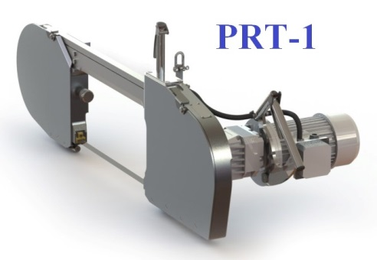
Technical characteristics
Voltage, frequency | 380V, 50Hz
Engine power | 2200W
Class/Level of protection | III/IP44
Consumption of electricity | 2.05 kW/h
Cable length | 8 m
Weight | 70 kg
Time for the 1 carcass cutting | 15-20 sec.
Overall dimensions, mm:
- length | 1390
- width | 550
- height | 500
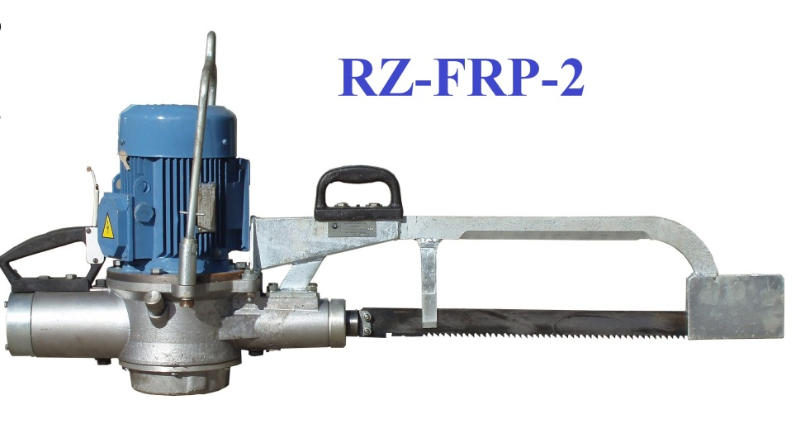
Technical characteristics
Power | 2200W
Rotation frequency | 1500 turn/min
Voltage, frequency | 380V, 50Hz
Consumption of electricity | 2.05 kW/h
Overall dimensions, mm:
- length | 1330
- width | 300
- height | 500
Weight | 63 kg
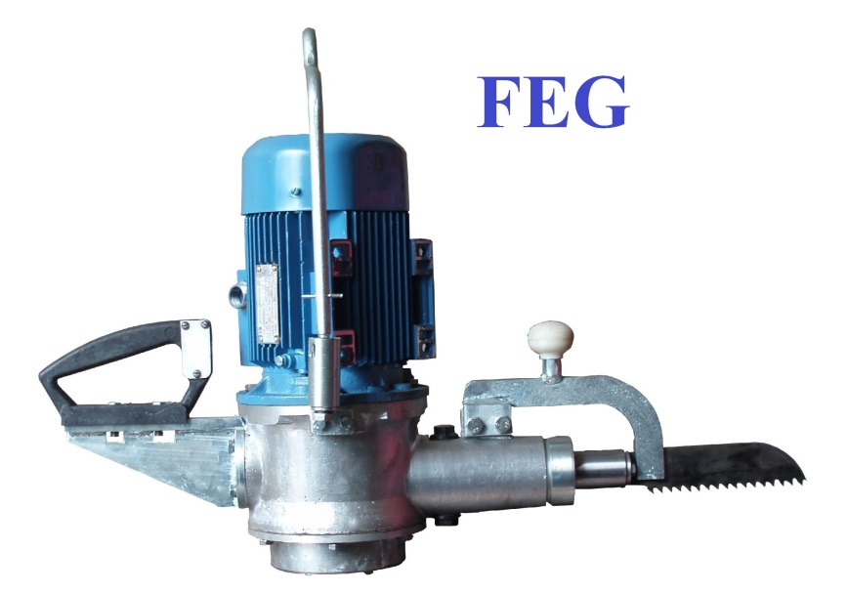

Technical characteristics
Power | 1100W
Rotation frequency | 920 turn/min
Voltage, frequency | 380V, 50Hz
Overall dimensions, mm:
- length | 740
- width | 280
- height | 450
Weight | 36 kg

Our contact information:
OJSC "Plant Minskagroprommash"
Republic of Belarus, Minsk, 39А, Glagoleva str.
Deputy chief of the marketing department Olga Suzko
tel. (+ 375 17) 2084995, 2082866
Our web-site: http://minskagroprommash.by
e-mail: minskagromash@inbox.ru
skype: minskagroprommash.

