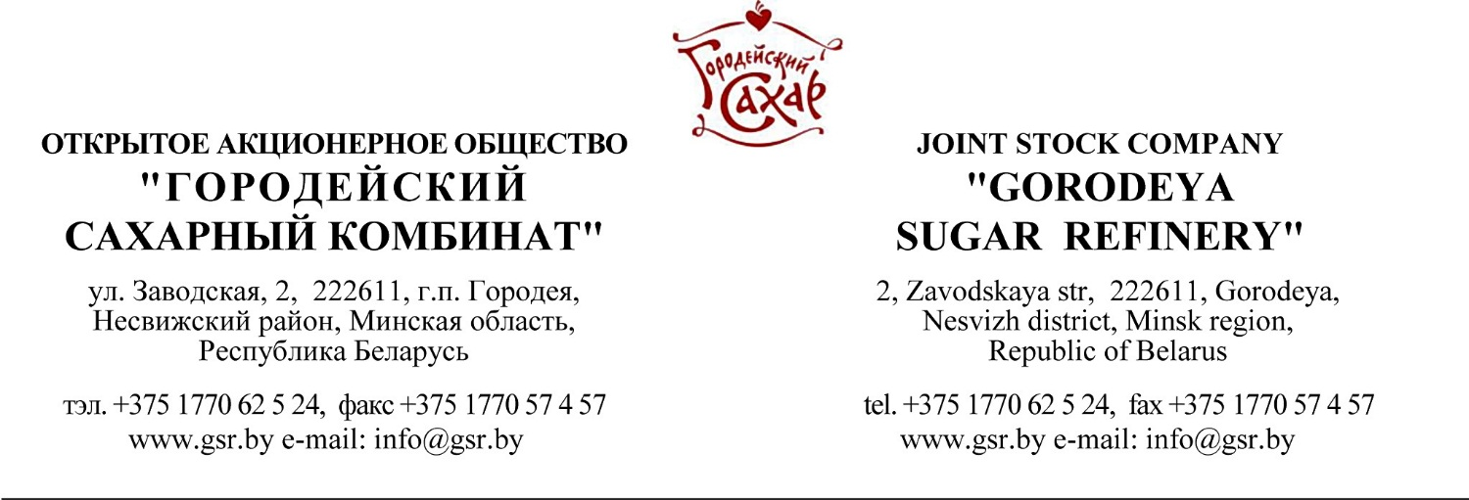
2015-06-08
Commercial Offer
Dear Sirs,
The JSC “Gorodeya Sugar Refinery” is an up-to date production facility equipped with everything necessary for output of a wide range of quality products. Our company is already 55 years is one of the leading sugar producers in the Republic of Belarus.
We can offer:
HS code/  bar code identification of goods | Product Name | Packing | Transport packing/ Number of consumer packages in transport package/ bar code | Product weight in consumer packaging, kg | Price per ton, USD
1701991009 or 1701991001/  4810272000037 | Granulated sugar  ГОСТ 21-94  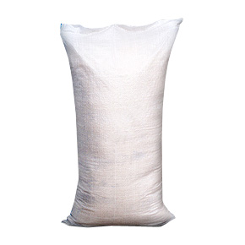 | PP bag with PE insert |  | 25,50 | 620
1701991009 or 1701991001/ | Granulated sugar  ГОСТ 21-94  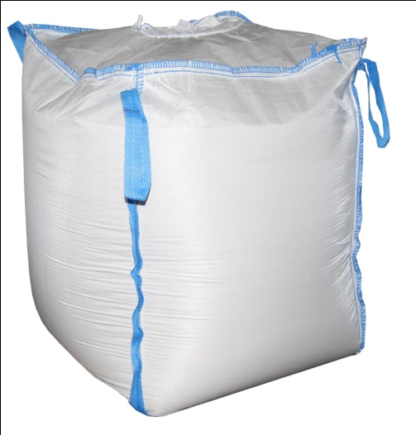 | PP big-bag |  | Till 960 kg | 610
1701991009 or 1701991001/  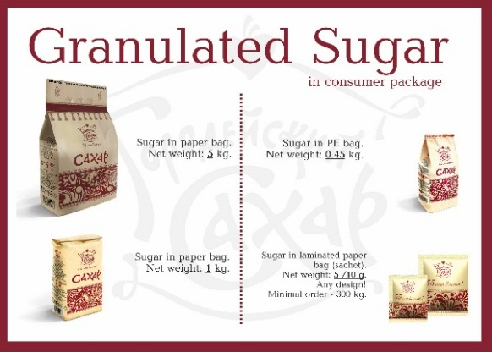 | Granulated Sugar in consumer package | Paper bag |  | 5 kg, 1 kg, 450 g, 10 g, 5 g | 670
1701991009 or 1701991001/ | Pressed sugar in cubes or shaped as card suits | Cardboard box | Corrugated paper box/  12 boxes/6 boxes | 500 g/1000 g | 700
1701999009 or 1701999001/ | Pressed sugar with additives: Cinnamon, Lemon, Wild Berries, Raspberry  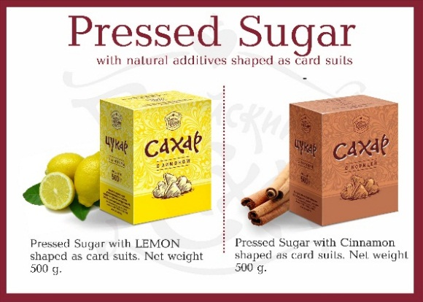 | Cardboard box | Corrugated paper box/  12 boxes | 500 g | 730-800
_____________________________________________________________________________________
Indicators of sugar, according to the test report №357 from 03.09.15 issued by RUE Slutsk Center for Standardization, Metrology and Certification, Department of tests of food and agricultural products to meet the requirements of the State Standard 21-94. White sugar. Technical conditions.
Physical and chemical indicators of sugar:  Moisture content  the mass fraction of sucrose (on dry substance,%)  Mass fraction of reducing substance (in terms of dry matter,%)  Ash content (based on dry matter,%)  color optical density units, IСUMSA  mass fraction of iron impurities,%  mass fraction of sulfur dioxide in mg / kg  microbiological parameters:  number of mesophilic aerobic and facultative anaerobic microorganisms, CFU in 1 g  fungi, CFU in 1 g  yeast CFU per 1 g  coliform bacteria (coliforms) in 1g  pathogenic microorganisms, including bacteria of the genus Salmonella, 25 g  heavy metals and arsenic mg / kg:  lead  cadmium  copper  zinc  arsenic  mercury | 0,03  99,90  0,02  0,024  22  not detected  not detected  5*10¹  Less 1*10¹  Less 1*10¹  not detected  not detected  0.06  0.010  0.33  0.35  Less 0.025  Less 0.005
Organoleptic characteristics:
Taste and smell: sweet, without foreign tastes and odors in dry sugar, and in its aqueous solution.
Flowability: bulk
Color: white, clean
Purity solution: a solution of sugar transparent without insoluble residue, mechanical and other impurities
_____________________________________________________________________________________

Terms of delivery: DAP Any Belarus border. Minimal order – for 1 truck (20 t assortment) or 1 rail car.
Terms of Payment: 100% prepayment.

For all additional questions you can contact by phone:
+375 (0) 1770 62445, +375 (0) 33 333 47 35 – Igor Moisenya
or contact with e-mail: i.moisenya@gsr.by

With hope of cooperation,

Commercial director A. Batskel

Finaeva Catherine
+375 (0)33 333 47 34

