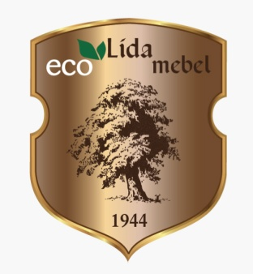 | Open joint-stock company  «Lida furniture factory»  JSC «Lida furniture factory»  str. 4, moprovskaja, 231300, str. Lida, Grodno region.  P/s 3012140374016 in the CBU № 401  JSC «Bps-SberBank» in the city. Lida,  MFIS 153001369, UNODC 500012155  Tel.: (0154) 52-86-78, tel./Fax (0154) 52-86-88  E-mail: market_lidamebel@mail.lida.by, www. lidamebel.by

Commercial offer

JSC «Lida furniture factory» manufacturer of furniture from solid birch and pine produces a wide range of Cabinet, office furniture and furniture for rural tourism direction. We are interested in reliable partners and regional dealers. For our counterparties, we are ready to provide:
- a diverse and original range of the furniture,
- guaranteed delivery,
- high-quality products,
- entitlement to technical and service maintenance outside Belarus,
- to build a modern stylish interiors and interiors in the style of «Provence» and «Country»,
- opportunities for designers and creators of the interior.
For the production and decoration of our furniture ecologically pure materials are used. Interesting and wide range of programs «Viking», «Viking GL», «Province». The program of furniture «Province» is made by an exclusive design development of solid birch, with the use of classic Italian furnishings. The color of the programmers emphasizes refinement and luxury furniture. Furniture of series «Viking» is made of solid pine with the effect of artificial ageing, simulating a «wormhole» and «wear». In the design of furniture decorative carved elements and accessories hand-forged. Products are processed composition on the basis of bees wax on the special technology. The structure of a tree when this becomes a bright and fully emphasizes natural beauty that creates the effect of «antique» furniture. The program of furniture « Viking GL » is made of solid pine with effect of artificial ageing, by sampling the interlayer wood, the method of «brushirovania»; finishing is made of ecologically clean water paint and varnish materials. Also factory specializes in the production of combined furniture for bedrooms «Gloria-6», «Gloria-8». Sets of furniture made from solid birch and (or) of a pine in conjunction with coated with natural veneer of the stove. Production of furniture for office and for the bedrooms of laminated chipboard in combination with elements of MDF, with the use of kromochnoy tape PVC and modern fittings. Code "TN VED 9403601009" - Wooden furniture for dining and living rooms other.

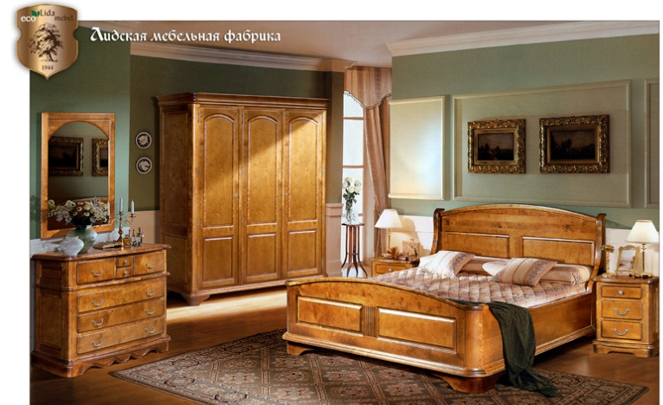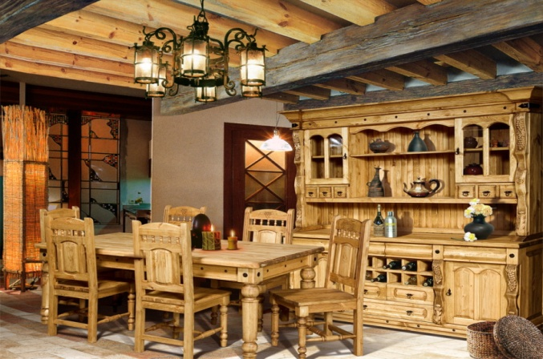

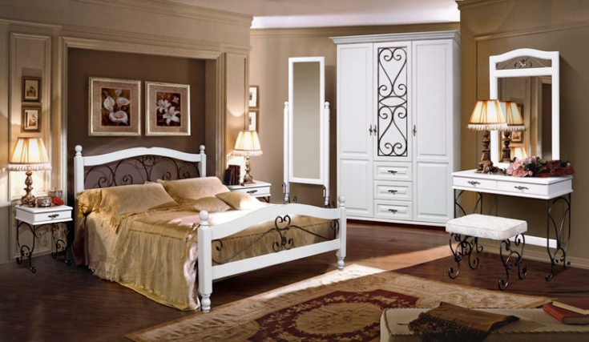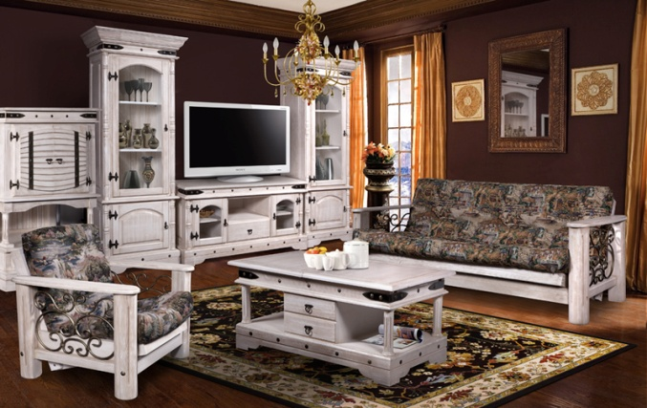
We are seeking to identify commercial partners, dealers and official representatives to promote our products in your region, delivery FCA-based.
Сonditions of sales – negotiations.
Our advantages:
- Own production capacities,
- Original design of the furniture made of natural, environmentally-friendly materials,
- Flexible terms of cooperation,
- Low wholesale prices, discounts depending on the conditions and terms of payment, volume of products purchased,
- Certificates of quality on the entire range of manufactured furniture (ISO 9001:2009).
Contacts:
Republic of Belarus, Grodnenskaya st., Lida, Moprovskaya street 4
Tel. +375 154 52-05-36, 52-94-94
e-mail: infolidamebel@mail.ru , lidamebel@mail.ru
www.lidamebel.by

With respect,
The Director of the A.A. Kozlov

Open joint-stock company "Lida Furniture Factory"

FCA, Lida 07.12.2015
“Viking” furniture
№ | Name of product | Price without VAT (USD)
 | Cupboard "Viking 01" | 275
 | Cupboard "Viking 02" | 255
 | Cupboard "Viking 04" | 156
 | Cupboard "Viking GL-05/01" | 454
 | Cupboard "Viking GL-05" | 520
 | Chest of drawers "Viking 04" | 192
 | Chest of drawers "Viking 02" | 130
 | Chest of drawers "Viking GL 05/01" | 258
 | Chest of drawers "Viking GL 05/03" | 233
 | Chest of drawers & bar "Viking GL 05" | 337
 | Chest of drawers & bar "Viking GL 05/01" | 314
 | Chest of drawers & bar "Viking GL 05/04" | 288
 | Bed "Viking 180" | 218
 | Bed "Viking 1,5" | 171
 | Bench "Viking" | 58
 | Dining table "Viking GL-05" | 153
 | Dining table "Viking GL-05" (200) | 162
 | Coffee table "Counsil" | 157
 | Writing desk “Viking” | 179
 | Chair "Viking GL-05" | 59
 | Trunk chest "Viking" | 105
 | Stool "Viking" | 29
 | Bar stand "Viking 01" | 192
 | TV stand "Viking" | 142
 | Wardrobe "Viking 03" | 180
 | Sofa "Viking 02" without the soft element | 190
 | Arm-chair "Viking 02" without the soft element | 150
 | Padded stool "Viking 02" without the soft element | 38
 | Bedroom set "Viking" | 905
 | > Bed "Viking 01" | 213
 | > Bed stand "Viking 02" | 73
 | > Wardrobe "Viking 02" | 324
 | > Chest of drawers "Viking 03" | 186
 | > Mirror "Viking" | 36
41. | Showcase “Viking GL” | 211
42. | TV stand "Viking GL" | 165
43. | Combined cabinet "Viking” 1722 04 | 381
44. | Combined cabinet "Viking”1250 05 | 311

“Viking” furniture (the method of «brushirovania»)

№ | Name of product | Price without VAT (USD)
1. | TV stand "Viking GL" | 230
2. | Showcase “Viking GL” | 291
3. | Padded stool "Viking 02" without the soft element | 277
4. | Arm-chair "Viking 02 without the soft element | 211
5. | Sofa "Viking 02" without the soft element | 54
6. | Coffee table "Counsil" | 219

“Province” furniture

№ | Name of product | Price without VAT (USD)
 | Sideboard P03B | 911
 | Bureau P01B | 519
 | Cabinet P02B | 475
 | Cabinet P03B | 500
 | Cabinet P04B | 461
 | Cabinet P05B | 298
 | Cabinet P06B | 388
 | Mirror P02B | 118
 | Locker P03B | 431
 | Locker P05B | 339
 | Console P01B | 387
 | Dining table P01B | 405
 | Table in writing P01B | 309
 | Table in writing P02B | 236
 | Chair P01B | 131
 | TV stand P03B | 361
 | Curbstone P04B | 465
 | Escritoire P02B | 299
 | Bench P01B | 228
 | Whatnot P01B | 181
 | Book wardrobe P01B | 842
24. | Wardrobe P02B | 662
25. | Bedroom set "Province" | 2162
 | > Bed P02B | 582
 | > Curbstone P01B | 142
 | > Wardrobe P03B | 800
 | > Locker P01B | 438
 | > Mirror P01B | 57

Grodno region, Lida, 4 Moprovskaya St.
Sales department: (0154) 52-05-36, 52-34-15, 52-94-94 fax: 52-97-81, 52-86-88,
E-mail: lidamebel@mail.ru
www.lidamebel.by

