Commercial offer

Company Information
Address and contact details (phone, fax, email, website) | JSC "Lakokraska", Lida  st. Ignatova, 71, Lida, 231300  ved@lidalkm.by; mark@lidalkm.by; support@lidalkm.by  www.lidalkm.by
Contact details of persons who speaks the respective foreign languages | Specialist of the Foreign Economic Activity Department - Danilovich Anastasia Ivanovna
Economic sector | Chemical
Sphere of activity | production and sale of paints materials, alkyd resins, phthalic anhydride and polyvinyl acetate dispersion
Trade marks | LIDA, OPTIMA, FRESKO, MASSIVE
Country of import | CIS countries, Asia, Africa, America
Potential importers

Name of product | Picture of product | Code of the  commodity nomenclature of foreign economic activity | Product characteristics, competitive advantages | Unit measurements,  qty  units packaged | Unit price .,  possible discounts | Availability of international quality certificates | Delivery conditions (min. And max.  lot  , transportation, storage) | Conditions for the sale of products (direct negotiations, tenders, sales through the trading exchange)
Phthalic anhydride | 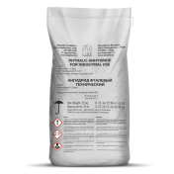 | 2917350000 | Phthalic Anhydride for industrial use Brand A Premium grade (white flakes and powder) | Bags 25kg; big bags 500kg | Valid price list | quality management system, in accordance with the requirements of STB ISO  9001-2015, environmental management system in accordance with requirements of  ISO 14001 | FCA Lida,  packing 20tn | direct negotiations through the subjects of the distribution network
Alkyd resins |  | 3907500000 | Alkyd resin solution in organic solvents: semi-finished varnish | railway tanks 60 tons; tank trucks 21tn; polyethylene cubes 1tn; metal drums, barrels | Valid price list |  | FCA Lida,  DAP | direct negotiations through the subjects of the distribution network
Paints materials | 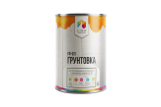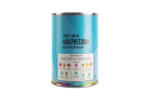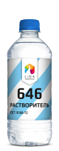 | 3208909109  3208209009  3208909900  3209100009  3814009000 | Paints, varnishes, enamels, primers on condensation resins enamels  (enamels PF, ML, EP; primers GF, PF, VL,  soil-enamels, etc.);  Enamels, primers, varnishes based on polymerization resins  (paint for road marking, enamel, primer,  HV varnishes; XC);  Varnishs based on nitrocellulose (NTs-218, NTs-237, NTs-243);  Water -dispersive  paints, varnishes and primers;  Solvents  (R-646, RE-4V, RCL,  R-4, R-4A, R-5, R-5A | Metal cans 1.0-2.0 kg, metal drum 50.0 kg,  plastic buckets | Valid price list |  | FCA Lida, | direct negotiations through the subjects of the distribution network
Dispersion polyvinyl acetate, PVA glue | 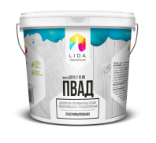 | 3905120000 | Dispersion: unplasticized  and plasticized |  |  |  | FCA Lida, | direct negotiations through the subjects of the distribution network

