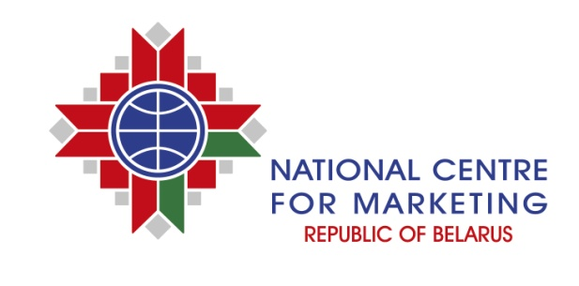
INFORMATION AND MARKETING SERVICES
The National Centre for Marketing of the Ministry of Foreign Affairs of the Republic of Belarus provides comprehensive information and marketing support to Belarusian and foreign companies in the promotion of products, services and trade.
One of the principle directions of activities of the National Centre for Marketing of the Republic of Belarus is carrying out a wide range of marketing research of commodity markets, both at the regional and global level.
Study of market indicators and trends
Providing information about the current state of the market, including analysis of the main indicators characterizing market, trends and prospects of its development.
Competitive analysis
Study of companies, product range and prices.
Study of customers and search for business partners
Searching for customers and determining the degree of their interest in acquisition of products, as well as definition of a product or service, the most significant factors influencing the customers’ choice. Searching for partners and suppliers of components, equipment, production lines, etc.
Comprehensive study of foreign markets
Comprehensive market research is the basis for making decision for the implementation of a company’s marketing strategy, including a strategy of access to foreign markets.
Consulting services
Recommendations for decision-making are based on market research results with a view to improve interaction between company with customers and suppliers of goods.
Preparation of analytical reviews
Preparation of analytical reviews of Belarusian and foreign markets of various products, including the analysis of data on market volume, foreign trade transactions, price movements, etc.
Advantages of cooperating with us are the following:
- more than 5000 market research, including the markets of the CIS countries, Europe, Asia, America and Africa for 20 years of presence on the market;
- partnership with more than 150 organizations in 48 countries;
- close cooperation with ministries, government bodies and foreign missions of the Republic of Belarus;
- highly qualified specialists with a command of foreign languages;
- branch offices in all major business hubs of the Republic of Belarus.

For further information please visit our websites: www.icetrade.by, www.ncmps.by, www.export.by, www.goszakupki.by.

Thank you for your attention.

