Commercial Offer

Open Joint-Stock Company “Glubokoe dairy-canning factory” offers mutually beneficial cooperation to wholesale companies and manufacturers for delivery of natural canned milk.
Open Joint-Stock Company “Glubokoe dairy-canning factory” was built and equipped to meet all international standards within the food industry.

Range of products manufacturing at our factory includes following groups:
- condensed canned milk;
- evaporated milk;
- milk powder;
- butter;
- cheese;
- whey.

Important competitive advantages of OJSC “Glubokoe dairy-canning factory” are
• high quality;
• using of natural raw materials;
• modern equipment from leading manufacturers;
• well-developed logistic system;
• clear positioning in the market.

The product quality corresponds to technical regulations for milk products. All products of the factory are certified. There are certificates of conformity HACCP, ISO, HALAL, FSSC.

The products of OJSC “Glubokoe dairy-canning factory” are delivered to the markets of Russia, Kazakhstan, Ukraine, the USA, Libya, Kingdom of Saudi Arabia, Turkmenistan, Azerbaijan, Israel, Georgia, Tajikistan, Uzbekistan, Kyrgyzstan, Mongolia, China.
We hope the products of our factory can compete with the goods presented in your market.
More detailed information about our factory you can find on our web-site www.glmkk.by.
We are sure contacting us you find a reliable and long-term partner.

Description of goods / Наименование продукции |  | H.S. code / Код ТН ВЭД | Quantity in a carton (pieces) / Кол-во в коробке | Shelf life / Срок годности | Unit Price FCA Glubokoe, USD / Прайс FCA Глубокое
Sweetened condensed milk full cream, 8,5 % fat, tin can 380g. / Молоко цельное сгущенное с сахаром м.д.ж. 8,5% в ж/б 380 гр. | 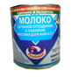 | 0402991000 | 30 | 18 | 0,69
Sweetened condensed milk full cream, 8,5 % fat, tin can 380g. with easy open end / Молоко цельное сгущенное с сахаром м.д.ж. 8,5% в ж/б 380 гр. c крышкой “easy open” | 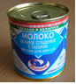 | 0402991000 | 30 | 18 | 0,73
Sweetened condensed milk full cream, 8,5 % fat, tuba 160g. / Молоко цельное сгущенное с сахаром м.д.ж. 8,5% в тубе 160 гр. | 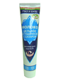 | 0402991000 | 30 | 12 | 0,45
Sweetened condensed milk full cream, 8,5 % fat, pouch 300g. / Молоко цельное сгущенное с сахаром м.д.ж. 8,5% в пакете «Дой-пак»300 гр. | 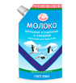 | 0402991000 | 30 | 12 | 0,60
Sweetened condensed milk full cream, 8,5 % fat, package «Bag-in-Box» 20 kg/ Молоко цельное сгущенное с сахаром м.д.ж. 8,5% , «Bag-in-Box» 20 кг | 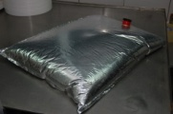 | 0402991000 | 1 | 8 | 1,55(1 kg)
Evaporated milk, 7,8 % fat, tin can 300g. / Молоко сгущенное стерилизованное м.д.ж. 7,8% в ж/б 300 гр. | 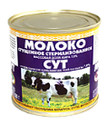 | 0402911000 | 45 | 18 | 0,46
Evaporated milk, 7,8 % fat, tin can 410g. / Молоко сгущенное стерилизованное м.д.ж. 7,8% в ж/б 410 гр. | 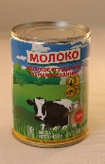 | 0402911000 | 30 | 18 | 0,62
Evaporated milk, 8,6 % fat, tin can 300g. / Молоко концентрированное стерилизованное м.д.ж. 8,6% в ж/б 300 гр. | 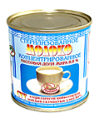 | 0402913000 | 45 | 18 | 0,48
Evaporated milk, 8,6 % fat, tin can 410g. / Молоко концентрированное стерилизованное м.д.ж. 8,6% в ж/б 410 гр. | 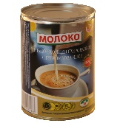 | 0402913000 | 30 | 18 | 0,65
“Lakomka” sweetened condensed milk boiled, tin can 380g. / Молоко сгущенное с сахаром вареное «Лакомка» м.д.ж. 8,5% в ж/б 380 гр. | 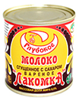 | 0402991000 | 30 | 10 | 0,75
Sweetened condensed milk fat-filled, 8,5 % fat, tin can 380g. /  Продукт сгущенный на основе молочной сыворотки с заменителем молочного жира м.д.ж. 8,5% в ж/б 380 гр. | 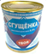 | 1901909900 | 30 | 12 | 0,42
Sweetened condensed milk with natural coffee 7,5% fat, tin can 380g/ Молоко сгущенное с сахаром и натуральным кофе 7% в ж/б 380 гр | 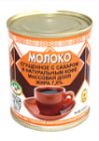 | 1901909900 | 30 | 12 | 0,99
Sweetened condensed milk with cocoa 7,5% fat, tin can 380g / Молоко сгущенное с сахаром и какао 7,5% в ж/б 380 гр. | 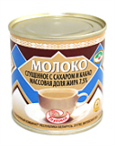 | 1806909000 | 30 | 12 | 0,90
Sweetened condensed milk with chicory 7,0% fat, tin can 380g  Молоко сгущенное с сахаром и цикорием 7% в ж/б 380 гр. | 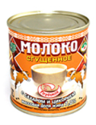 | 1901909900 | 30 | 12 | 0,90
Sterilized drinking milk, 3,2% fat in Brick-Aseptic, 1 l. / Молоко питьевое стерилизованное м.д.ж. 3,2% | 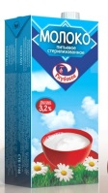 | 0401209109 | 12 | 12 | *
Sterilized drinking milk , 2,5% fat in Brick-Aseptic, 1 l. / Молоко питьевое стерилизованное м.д.ж. 2,5% | 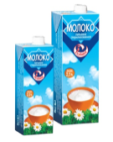 | 0401201109 | 12 | 12 | *
Sterilized drinking milk , 1,5% fat in Brick-Aseptic, 1 l. / Молоко питьевое стерилизованное м.д.ж. 1,5% |  | 0401201109 | 12 | 12 | *
Cheese whey powder /  Сыворотка молочная сухая подсырная | 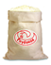 | 0404100200 | 25 kg | 6 | 0,70/1 kg
Demineralized whey powder 50 / Сыворотка деминерализованная СД 50 |  | 0404100200 | 25 kg | 12 | 0,77/ 1 kg
* temporarily out of stock
Delivery terms: FCA
Payment terms: 100% advance payment
131, Lenina str., Glubokoe, Vitebsk region, 211793, Republic of Belarus
Deputy generalndirector of the processing industry: Andrey Sokolovsky,
tel. + 375 -2156-5-49-06.
Foreign Trade Activity Department: tel.+ 375-2156-5-51-32, 5-49-02.
Tel/fax + 375-2156-5-51-10
Acting Head of Foreign Trade Activity Department Elena Lavrinovich
E-mail: ved@glmkk.by, info@glmkk.by
www.glmkk.by
English speaking specialist Anastasiya Lyashkevich E-mail: nastya@glmkk.by

