КОНЦЕРН "БЕЛЛЕГПРОМ" ОТКРЫТОЕ АКЦИОНЕРНОЕ ОБЩЕСТВО

“ К А М В О Л Ь”
ул. Маяковского, 176, 220028, г. Минск
Тел.: 223 14 18 - приемная,
223 14 14 – справка, факс 223 75 75,
Р/с 3012005965966, ЗАО "РРБ-Банк"
код 110, г. Минск
УНН 100074393 ОКПО 00312099
КАНЦЭРН "БЕЛЛЕГПРАМ" АДКРЫТАЕ АКЦЫЯНЕРНАЕ ТАВАРЫСТВА

“ К А М В О Л Ь”
вул. Маякоўскага, 176, 220028, г. Мiнск,
Тэл.:223 14 18 - прыемная,
223 14 14 – даведка, факс 223 75 75,
Р/р 3012005965966, ЗАТ "РРБ-Банк"
код 110, г. Мiнск
УНН 100074393 AKПA 00312099

_____________№_____________
На №________от _____________

Embassy of the Republic of Belarus
in the Bolivarian Republic of Venezuela

SP «Venbelkom»

Сommercial Offer

Joint Stock Company «Kamvol» - the largest enterprise of textile products, which has a complete production cycle: from wool processing, yarn manufacturing, to production and supply of tissue products in Europe and the CIS.

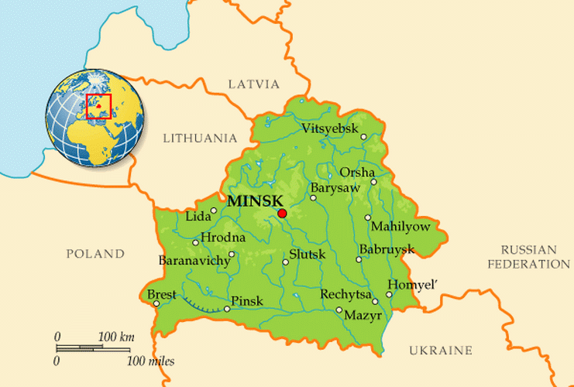
At present JSC «Kamvol» can offer you a wide assortment of modern-dress costume and trousers pure wool (HS code 5112110000, 5112191000, 5112199000), wool (HS Code 5112301000,5112303000, 5112309000), half-woolen fabrics (HS code 5515139900), with embedding of polyester, viscose, nitron, elastane yarns "Lycra", tissue from the man-made fibers (HS Code 5515119000, 5516930000), including high quality fabric of Australian wool, fabrics of his jacket’s destination ("Tweed" type), a wide variety of cells, fabric - companions. Half-woolen fabrics (military, corporate, departmental and school groups) make a great amount of production and sales in the worsted assortment now.
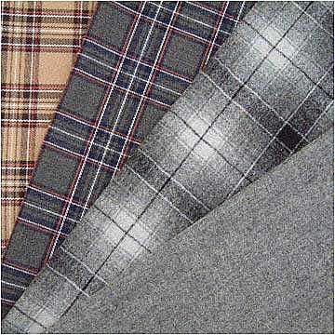
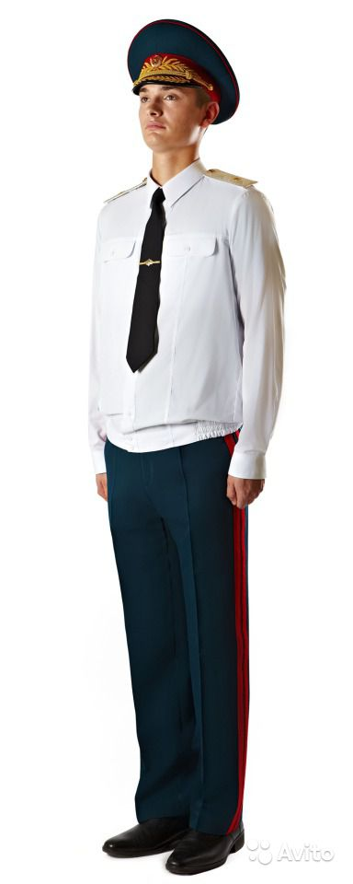

Using in the production the best Swiss and German colors and import equipment allows the company to produce high quality products, which is different from competitor’s products. To improve the protective properties of fabrics, we offer a range of special types of finishes: softening, oil-mud-water-repellent, antistatic. All fabrics have excellent physical and mechanical properties, they are resistant to washing, mechanical impacts, require minimal maintenance, little creasing and durable.

Some kinds of the manufactured fabrics and their characteristics:

No. | Article | Width with edges, cm | Weight, g/m² | Сomposition | Interweaving | Price USD, for one running meter  (VAT = 0%)
School group
1 | 05С4 | 152-2,5 | 235 | 100 Wool | Twill 2/2 | 13,8
2 | 04С41с | 152-2,5 | 214 | 45Wool/55PE | Twill 2/1 | 8,1
3 | 05С50с | 152-2,5 | 210 | 45Wool/55PE | Twill 2/1 | 9,0
4 | 05С53с | 152-2,5 | 192 | 45Wool/55PE | Combined weave | 8,2
5 | 06C22c | 152-2,5 | 160 | 45Wool/55PE | Plain weave | 7,5
6 | 06C50c | 152-2,5 | 195 | 45Wool/55PE | Twill 2/2 | 7,8
7 | 06C58c | 152-2,5 | 223 | 45Wool/55PE | Twill 2/2 | 9,2
8 | 07C65c | 152-2,5 | 202 | 43Wool/55PE/2 Lycra | Twill 2/1 | 8,7
9 | 07С70с | 152-2,5 | 210 | 43Wool/55PE/2 Lycra | Twill 2/1 | 8,6
10 | 09C32c | 152-2,5 | 227 | 27Wool/49PE/24 Viscose | Twill 2/2 | 7,8
11 | 09С43с | 142-2,0 | 202 | 20Wool/54PE/23 Viscose/3 Lycra | Plain weave | 7,5
12 | 14С30с | 148-2,0 | 225 | 20Wool/78PE/2 Lycra | Twill 2/1 | 8,1
13 | 14С33с | 152-2,5 | 217 | 33Wool/67PE | Twill 2/1 | 7,8
Military / departmental group
14 | 02С54с | 152-2,5 | 360 | 55Wool/45PE | Diagonal weave | 14,3
15 | 02С55 | 152-2,5 | 317 | 67Wool/33PE | Twill 2/2 | 13,8
16 | 03С46с | 152-2,5 | 257 | 45Wool/55PE | Twill 2/2 | 11,1
17 | 03С58с | 152-2,5 | 238 | 55Wool/45PE | Plain weave | 8,7
18 | 05С55 | 152-2,5 | 300 | 66Wool/34PE | Diagonal weave | 13,3
19 | 05С67с | 152-2,5 | 240 | 33Wool/67PE | Twill 2/2 | 7,8
20 | 06С21с | 152-2,5 | 153 | 45Wool/55PE | Plain weave | 7,2
21 | 07С63с | 152-2,5 | 270 | 45Wool/55PE | Twill 2/1 | 9,3
22 | 07С64 | 152-2,5 | 340 | 70Wool/30PE | Diagonal weave | 15,4
23 | 07С69с | 152-2,5 | 288 | 33Wool/67PE | Diagonal weave | 10,0
24 | 08С63с | 152-2,5 | 265 | 50Wool/50PE | Twill 2/2 | 10,7
25 | 12С47с | 152-2,5 | 264 | 44Wool/54PE/2 Lycra | Twill 2/2 | 10,7
26 | 13С27 | 152-2,5 | 280 | 65Wool/35PE | Twill 2/1 | 11,5
27 | 14С46с | 152-2,5 | 208 | 40Wool/60PE | Twill 2/1 | 7,6
Business suit and costume group
28 | 05C49c | 152-2,5 | 222 | 45Wool/55PE | Satin weave | 8,5
29 | 07C68c | 152-2,5 | 195 | 45Wool/55PE | Twill 2/2 | 8,2
30 | 07С74с | 152-2,5 | 250 | 45Wool/55PE | Twill 3/3 | 10,3
31 | 10С35с | 152-2,5 | 226 | 25Wool/53PE/22 Viscose | Twill 2/2 | 7,7
32 | 10С45с  australian tops | 152-2,5 | 179 | 45Wool/55PE | Combined weave | 10,5
33 | 12С45с | 152-2,5 | 210 | 45Wool/55PE | Combined weave | 8,7
34 | 14С34с | 152-2,5 | 202 | 33Wool/67PE | Twill 2/2 | 7,7
35 | 15С77с | 150-2 | 190 | 35Viscose/65PE | Combined weave | 5,0
Except fabrics, we produce and sell yarn (N14, 9x1/14, 9x2 - 55.5x1/55.5x2, etc.) – with using wool fibers, polyester, nitron, flax in various combinations, knitting and weaving.
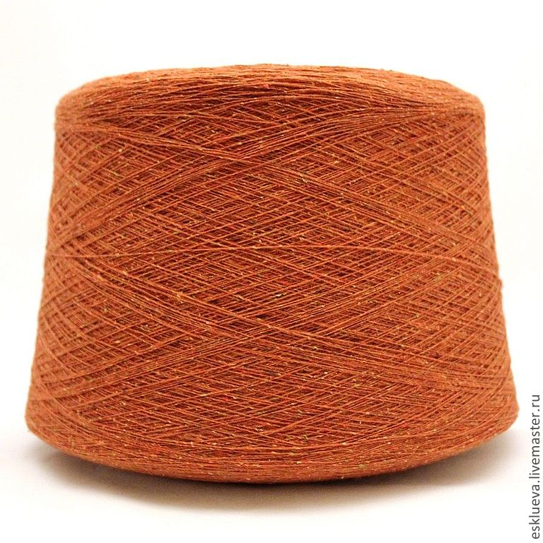
Thorough quality control starts with the selection of raw materials and continues until getting the final product. This is confirmed by a certificate of quality management system according to the requirements of STB ISO 9001-2009, the availability of sanitary certificates Ministry of Health of Republic of Belarus and certificates of conformity.

We offer our partners:
• Wide assortment of fabrics of high quality;
• Continuous updating of the collection of fabrics;
• Flexible system of discounts;
• Organization deliveries of the orders;
• High level of service;
• Advertising support.
Terms of delivery: FCA, Мinsк (Incoterms 2010).
Term production of fabric: 80 calendar days after receiving advance payment on account JSC «Kamvol».
An order fabric: from 1000 m in one color and also you can take out fabric in the stock.
Payment terms: 100% in advance.
More information is on our web-site www.kamvol.by.
Whether you have any questions, please do not hesitate to contact us. We hope for your interest in our offer. We will be glad to cooperate.

Contact information:

JSC «Kamvol»
Address: 220028 Minsk, str. Mayakovskogo, 176. The Republic of Belarus.
E-mail: kamvol@tut.by, kamvol@bk.ru

General Director
Anatolij Zhabort +375 17 2231418 / +375 17 2237575

Deputy Genereal Director of Commercial Questions
Aleksandr Jacenko + 375 17 2231580

Best regards,
General Director JSC «Kamvol» Zhabort A.G.
zhabort@tut.by

Sinkevich Viktorija, +37517 223 20 08

