**COMMERCIAL OFFER**

**for the supply of the machinery**

**produced by “GOMSELMASH”**

Today holding “GOMSELMASH” is one of the largest manufacturers of the agricultural machinery in the world. “GOMSELMASH” produces a range of different types of agricultural machinery and implements under the brand “PALESSE” in accordance to modern agricultural technologies.

Contact information: 246004, Republic of Belarus, Gomel, Shosseynaya 41.

<http://www.gomselmash.by/> ; [ftd2.sel@gmail.com](mailto:ftd2.sel@gmail.com)

Contact persons:

− Yuri N. Rafeev, deputy sales director.

− Mark V. Nemanov, specialist of foreign countries sales department (speaks English).

Tel.: +375 232 59 18 09 ; Tel./fax: +375 232 54 12 06

The prices are presented in FCA Gomel terms, and may be updated at the moment of signing of sales contract of the machinery.

**Self-propelled grain-harvesting combine KZS-5 “PALESSE GS05”**

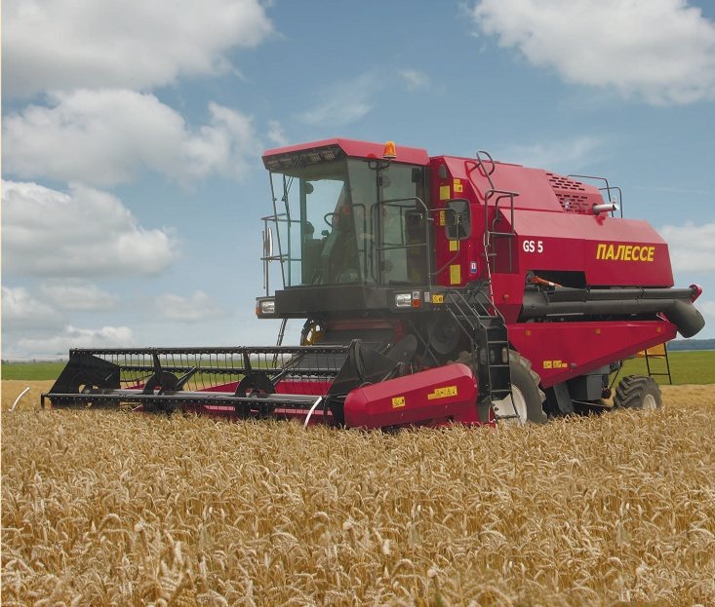The combine harvester KZS-5 is intended for direct and windrow harvesting of cereals, it can also be used for harvesting of leguminous and rape on plain fields with slope level up to 8º using special equipment.

The harvester GS-5 provides cutting, threshing, separation, cleaning of grain, collecting of grain in the bunker and its unloading, and it also provides harvesting of non-cereal part of crops with laying of straw into swath.

The combine harvester works in all soil-climatic zones, except mountainous regions.

The harvester PALESSE GS5 has classical design: one threshing drum, a bitter and straw-shaker.

SPECIFICATIONS

|  |  |  |
| --- | --- | --- |
| **Characteristics** | **Measuring unit** | **Value** |
| Engine |  | Diesel MMZ D-260.9 |
| Nominal engine power | kW (HP) | 132 (179,5) |
| Fuel tank volume | l | 300 |
| Threshing drum width | mm | 1200 |
| Threshing drum diameter | mm | 800 |
| Straw shaker type |  | 4 keys |
| Separation area, not less than | m2 | 4,92 |
| Total sieve area, not less than | m2 | 3,86 |
| Total separation area of concave, not less than | m2 | 1,37 |
| Grain bunker volume, not less than | m3 | 4,5 |
| Header capturing width | m | 4,0; 5,0 |
| Throughoutput on grain mass, not less than | kg/sec | 5,0-6,0 |
| Productivity on grain harvesting in 1 hour, not less than | ton/hour | 7,2 |

**Self-propelled grain harvesting combine KZS-812 “PALESSE GS812”**

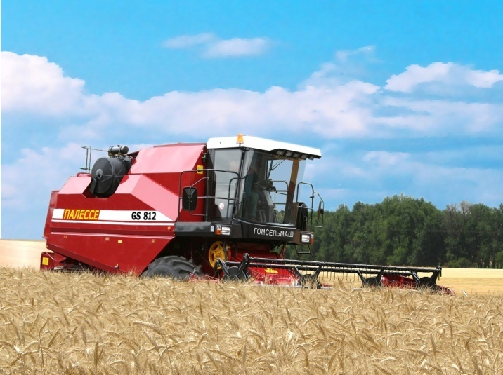The combine harvester PALESSE GS812 is intended for direct and windrow harvesting, it can also be used for harvesting of maize, sunflowers, leguminous and rape using special equipment.

PALESSE GS812 harvests non-cereal part of crops due to the following technological schemes:

- straw crushing and throwing across the field;

- straw laying into swath.

The combine harvester is serially equipped with grain header with 6 m capturing width with trolley. The following equipment can be delivered as options:

- grain headers with 5 m and 7 m capturing width;

- grain pick-up PZ-3,4 with 3,4 m capturing width;

- equipment for rape harvesting PR-5 with 5 m capturing width, PR-6 with  
6 m capturing width, PR-7 with 7 m capturing width;

- equipment set with 6-row header for maize harvesting KOK-6-3-01;

- modified header for grain and soy harvesting ZhZS-6-1 and ZhZS-7-1 with 6 m and 7 m capturing width respectively;

- equipment for sunflower harvesting PS-8-1 (8 rows).

The combine harvester PALESSE GS812 is certified to conformity requirements of European community with the right to apply ce_1-mark.

SPECIFICATIONS

|  |  |  |
| --- | --- | --- |
| **Characteristics** | **Measuring unit** | **Value** |
| Engine |  | YaMZ-236 NE2-47 |
| Nominal engine power | kW (HP) | 169 (230) |
| Fuel tank volume | l | 500 |
| Threshing drum width | mm | 1200 |
| Threshing drum diameter | mm | 800 |
| Straw shaker type |  | 4 keys |
| Separation area, not less than | m2 | 4,92 |
| Total sieve area, not less than | m2 | 3,86 |
| Total separation area of concave, not less than | m2 | 1,096 |
| Grain bunker volume, not less than | m3 | 5,5 |
| Header capturing width | m | 6,0 |
| Throughoutput on grain mass, not less than | kg/sec | 8,0 |
| Productivity on grain harvesting in 1 hour, not less than | ton/hour | 12,0 |

**Self-propelled grain-harvesting combine KZS-10K “PALESSE GS10”**

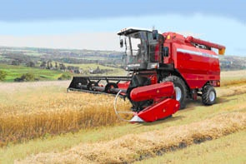

The combine harvester is intended for direct and windrow harvesting and it can also be used for harvesting of maize, sunflowers, leguminous, cereal crops, grass and rape seeds using special equipment.

Combine harvests non-cereal part of crops due to the following technological schemes:

- straw crushing and throwing across the field;

- straw laying into swath.

The combine harvester is serially equipped with header for harvesting of grain crops with 7 m capturing width with trolley. The following equipment can be delivered as options:

- grain headers with 6 m and 9,2 m capturing width;

- grain pick-up PZ-3,4 with 3,4 m capturing width;

- equipment for rape harvesting PR-6 with 6 m capturing width, PR-7 with  
7 m capturing width;

- equipment set with 6-row header for maize harvesting KOK-6-1-01;

- modified header for grain and soy harvesting ZhZS-6-1 and ZhZS-7-1 with 6 m and 7 m capturing width respectively;

- equipment for sunflower harvesting PS-8 (8 rows) and PS-12 (12 rows).

SPECIFICATIONS

|  |  |  |
| --- | --- | --- |
| **Characteristics** | **Measuring unit** | **Value** |
| Engine |  | YaMZ-236BE2 |
| Nominal engine power | kW (HP) | 184 (250) |
| Threshing drum width | mm | 1500 |
| Threshing drum diameter: | mm | 800 |
| Straw shaker type |  | 5 keys |
| Separation area, not less than | m2 | 6,15 |
| Total sieve area, not less than | m2 | 5,0 |
| Total separation area of concave, not less than | m2 | 1,37 |
| Grain bunker volume, not less than | m3 | 7,0 |
| Header capturing width | m | 7,0 |
| Fuel tank volume | l | 500 |
| Throughoutput on grain mass, not less than | kg/sec | 10,0 |
| Productivity on grain harvesting in 1 hour, not less than | ton/hour | 15,0 |

**Self-propelled grain harvesting combine KZS-1218 “PALESSE GS12”**

**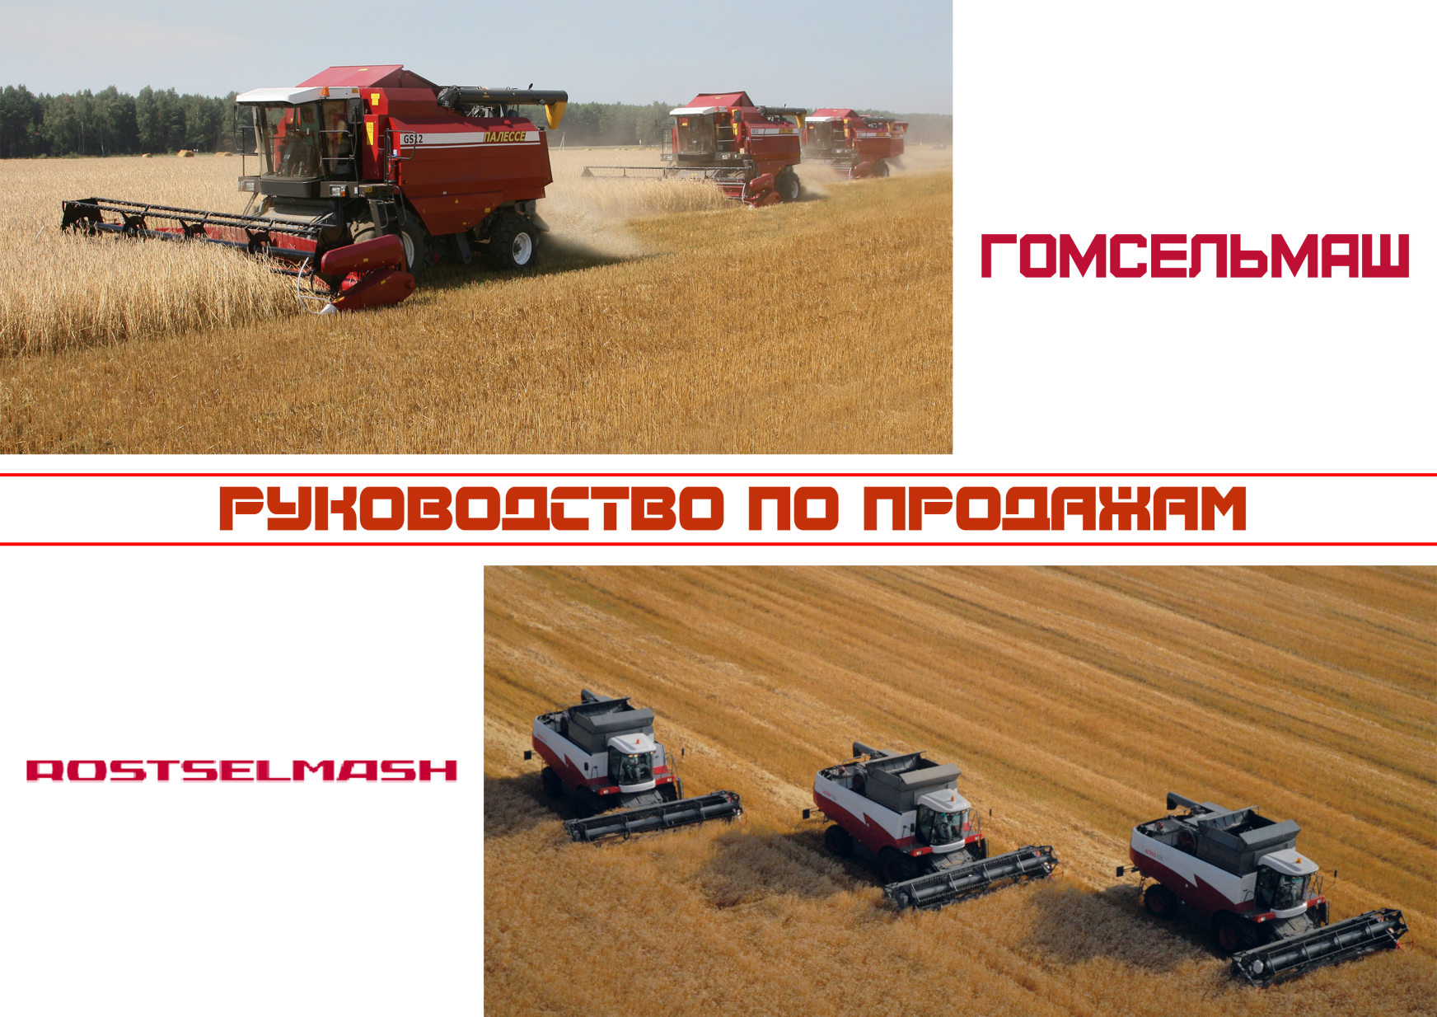**The combine harvester is intended for direct and windrow harvesting and it can also be used for harvesting of of maize, sunflowers, leguminous, cereal crops, grass and rape seeds using special equipment.

Combine harvests non-cereal part of crops due to the following technological schemes:

- straw crushing and throwing across the field;

- straw laying into swath.

The combine harvester is serially equipped with header for harvesting of grain crops with 7 meters capturing width with trolley. The following equipment can be delivered as options:

- grain headers with capturing width 6 and 9,2 meters;

- grain pick-up PZ-3,4 with 3,4 m capturing width;

- equipment for rape harvesting PR-6 with 6 m capturing width, PR-7 with  
7 m capturing width;

- equipment set for maize harvesting KOK-6-2-01 with six-row header and KOK-8-2-01 with eight-row header;

- modified header for grain and soy harvesting ZhZS-6-1 and ZhZS-7-1 with 6 and 7 meters working width respectively.

- equipment for sunflower harvesting PS-8-2 (8 rows) and PS-12-1 (12 rows).

The combine harvester PALESSE GS12 is certified to conformity requirements of European community with the right to apply ce_1-mark.

SPECIFICATIONS

|  |  |  |
| --- | --- | --- |
| **Characteristics** | **Measuring unit** | **Value** |
| Engine |  | Mercedes Benz OM 926 LA 3B |
| Nominal engine power | kW (HP) | 240 (326) |
| Threshing drum width | mm | 1500 |
| Threshing drum diameter: | | |
| - first | mm | 600 (boosting drum) |
| - second | mm | 800 (threshing drum) |
| Straw shaker type |  | 5 keys |
| Separation area, not less than | m2 | 6,15 |
| Total sieve area, not less than | m2 | 5,0 |
| Total separation area of concave, not less than | m2 | 2,39 |
| Grain bunker volume, not less than | m3 | 8,0 |
| Header capturing width | m | 7,0 |
| Throughoutput on grain mass, not less than | kg/sec | 12,0 |
| Productivity on grain harvesting in 1 hour, no less | ton/hour | 18,0 |

**Self-propelled forage harvester KSK-600 "PALESSE FS60"**

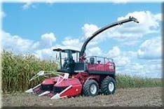

KSK-600 "PALESSE FS60" is intended for mowing down maize of any ripeness stage, sunflower and other high-stemmed crops, mowing down grass and picking up slightly dried seeded and natural grass from swaths with simultaneous chopping and loading of the mass into transport trailer.

Five meters width header for grass harvesting, pick-up and rotary header for rough-stemmed crops make effective application of combine in wide yield range of forage crops. KSK-600 is stable in harvesting forage crops in any harvesting conditions.

The combine harvester PALESSE FS60 is certified to conformity requirements of European community with the right to apply ce_1-mark.

SPECIFICATIONS

|  |  |  |
| --- | --- | --- |
| **Characteristics** | **Measuring unit** | **Value** |
| **Engine** | | |
| Model |  | YaMZ-238AK-1 |
| Nominal engine power | kW (HP) | 172 (235) |
| **Productivity in 1 hour** | | |
| Harvesting of milk-wax ripened maize (humidity 80%, yield not less 45 t/hectare) | t/h | 108 |
| Harvesting of wax ripened maize, yield not less 30 t/hectare | t/h | 43 |
| Picking-up of slightly dried grass (humidity 55% from swath with density of not less 12 kg/m) | t/h | 39 |
| Harvesting of grass (humidity 75%), yield not less 20 t/hectare | t/h | 54 |
| **Adapters** | | |
| Rough-stemmed crops header | m | 3 |
| Grass header | m | 5 |
| Pick-up | m | 3 |
| **Feeding unit** | | |
| Type |  | drum |
| Width | mm | 648 |
| Diameter | mm | 750 |
| **Cutting height** | | |
| Rough-stemmed crops header | mm | 120 - 300 |
| Grass header |  | from 60 up to 120 |
| Field copying device |  | serial |
| Angle of silage duct rotation | ° | 270 |
| Quantity of knives | pcs. | 12/6/3 |
| Cutting length | mm | 4,2-52 |
| Loading height of chopped mass into the transport, not less | m | 3,5 |
| Fuel tank volume | l | 400 |

**High efficient forage harvesting complex KVK-800 "PALESSE FS80-2"**

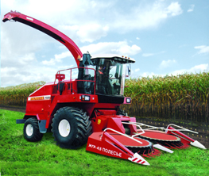

KVK-800 "PALESSE FS80-2" is intended to mow down maize of any ripeness stage and other high-stemmed crops, to pick up slightly dried seeded and natural grass from swaths with simultaneous chopping and loading of the mass into transport trailer.

The machinery is intended for stable functioning with the high quality of chopping in the most difficult conditions.

SPECIFICATIONS

|  |  |  |
| --- | --- | --- |
| **Characteristics** | **Measuring unit** | **Value** |
| **Engine** | | |
| Model |  | D-280-1S2 |
| Nominal engine power | kW (HP) | 330 (450) |
| **Productivity in 1 hour** | | |
| Harvesting of milk-wax ripened maize (humidity 80%, yield not less 45 t/hectare) | t/h | 160 |
| Harvesting of wax ripened maize, yield not less 30 t/hectare | t/h | 120 |
| Picking-up of slightly dried grass (humidity 55% from swath with density of not less 12 kg/m | t/h | 85 |
| **Adapters** | | |
| Header for rough-steamed crops | m | 4,5 |
| Pick-up | m | 3,0 |
| **Feeding unit** | | |
| Width | mm | 770 |
| Quantity of rolls | pcs. | 4 |
| **Chopping unit** | | |
| Type |  | drum-type |
| Quantity of knives on the drum | pcs. | 40 |
| Variants of knives mounting | mm | 20; 40 |
| Adjustable height of cutting for rough-steamed crops | mm | 120-300 |
| **Cutting length** | mm | 5-26 |
| **Regrinding device** | | |
| Type |  | twin rolls, with riffled cylindrical rolls |
| Roll diameter | mm | 196 |
| Grinding rate of wax-ripened maize grain, no less | % | 96 |
| **Loading height of chopped mass into the transport, not less than** | m | 4,0 |
| Fuel tank volume | l | 550 |

**Forage harvesting complex “K-G-6 PALESSE”**

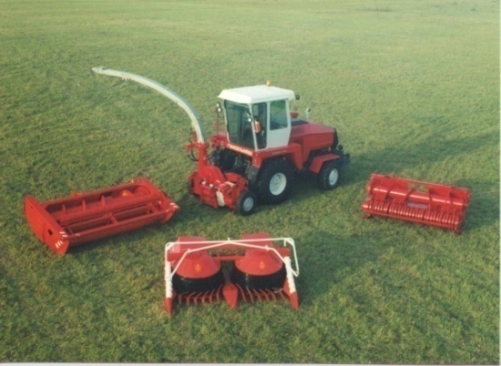Forage harvesting complex “K-G-6 PALESSE” is intended for harvesting of maize, including wax and full-ripened maize, other high-stemmed crops, also for mowing green and picking-up slightly dried, sowed and natural grass from swaths, chopping and loading into transporter-wagons. Forage harvesting complex “K-G-6 PALESSE” includes universal power vehicle, chopping device, pick-up, header for rough-stemmed crops, grass header with trolley.

“K-G-6 PALESSE” with universal power vehicle UES-2-280-A (4 wheel drive and with the conditioner) provides stable forage harvesting in extreme conditions (on hard soils, in rainy conditions, while harvesting of wax ripened maize in autumn).

“K-G-6 PALESSE” with universal power vehicle UES-280 with one driving axle has a more simple design and has the same productivity as UES-2-280-A. This complex is used on medium and light soils.

SPECIFICATIONS

|  |  |  |
| --- | --- | --- |
| **Characteristics** | **Measuring unit** | **Value** |
| **Engine** | | |
| Model |  | YaMZ-238BK-3 |
| Nominal engine power | kW (HP) | 213 (290) |
| **Productivity per 1 hour** | | |
| Harvesting of milk-wax ripened maize (humidity 80%, yield not less 45 t/hectare) | t/h | 90 |
| Harvesting of wax ripened maize (maize cobs yield not less 10 t/hectare) | t/h | 43 |
| Picking-up of slightly dried grass (humidity 45% from swath with density of not less 6 kg/m) | t/h | 50 |
| Harvesting of grass (humidity 75%, yield not less 20 t/hectare) | t/h | 43 |
| **Adapters** | | |
| Header for rough-stemmed crops | m | 3,0 |
| Pick-up | m | 2,2/3,0 |
| Grass header | m | 4,2 |
| Chopping device | type | radial-disc |
| **Cutting height** | | |
| Header for rough-stemmed crops | mm | 100-140 |
| Grass header | mm | 60 |
| Angle of silage duct rotation | ° | 270 |
| Quantity of knives | pcs. | 12/6/3 |
| Cutting length | mm | 5-48 |
| Rate of maize grains cracking | % | not less 96 |
| Loading height of chopped mass into the transport, not less | m | 4,0 |

**Pull-type forage harvester KDP-3000 “PALESSE FT40”**

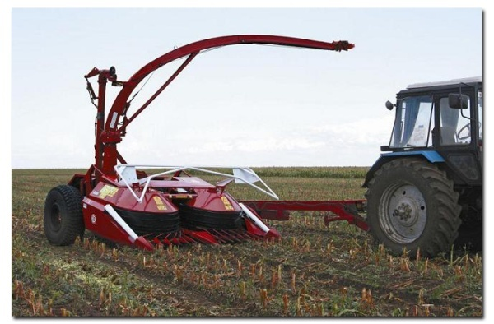Pull-type harvester KDP-3000 “PALESSE FT40” is intended for harvesting maize, including wax-ripened and complete ripeness maize, sorgo, sunflower and other tall-stalked crops, mowing green crops, picking-up mass from swaths of prewilted sowed and natural grass with simultaneous crushing and loading into the transporter-wagon.

The harvester “PALESSE FT40” includes pull-type chopper, rotating header for rough-stemmed crops harvesting, grass mower and a pick-up.

SPECIFICATIONS

| **Characteristics** | **Measuring unit** | **Value** |
| --- | --- | --- |
| Type |  | Pull-type |
| **Aggregation with tractors** | | |
| Drawbar category |  | 2-4 |
| Required power of tractor | kW  (HP) | 110-185 (150-250) |
| **Harvester output per 1 operation hour with tractors of 120 kW (160 HP)** | | |
| harvesting mil-wax ripened maize | t/h | 43 |
| harvesting wax-ripened maize | t/h | 16 |
| picking-up prewilted grass | t/h | 25 |
| grass mowing | t/h | 26 |
| **Platforms** | | |
| Rough-stemmed crops header | m | 3,0 |
| Pick-up | m | 1,85/2,6 |
| Grass mower | m | 3,4 |
| **Flywheel chopper** | | |
| Maximum quantity of knives / blades on the cutter wheel | pcs | 12/12 |
| Knives and blades position |  | radial |
| **Overall dimensions in transport position** | | |
| Length | mm | 8 500 |
| Width | mm | 4 440 |
| Height | mm | 3 650 |
| Weight | kg | 6 180 |

**Rotary mounting mower-flattener KPR-9, KPR-9-01 “PALESSE CH90”**

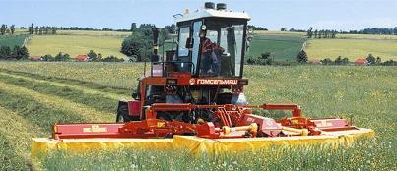KPR-9 “PALESSE CH90” mower is intended for cutting of green seeded and natural grass with simultaneous flattering and laying of mowed mass into three swaths in conditions of temperate zone at flatland with 80 grades, with stones, which overhangs up to 40 mm above the earth surface.

Rotary mounting mower-flattener KPR-9 is intended for integrating with universal power vehicles produced by “GOMSELMASH” (can be purchased separately), KPR-9-01 operates with universal power vehicles produced by “GOMSELMASH” and with tractors.

PALESSE CH90 is certified to conformity requirements of European community with right to apply- mark.

SPECIFICATIONS

|  |  |  |
| --- | --- | --- |
| **Characteristics** | **Measuring unit** | **Value** |
| Productivity | hectare/h | 10 |
| Completeness of grass stem flattering, not less than | % | 80 |
| Total losses, up to | % | 2 |
| Swath width, up to | m | 1,8 |
| Capturing width | m | 8,7 |
| Adjustable cutting height | mm | 50; 100 |
| Working speed, up to | km/h | 12 |
| Overall dimensions and weight, up to | | |
| Length | mm | 3900 |
| Width | mm | 9500 |
| Height | mm | 1600 |
| Constructional weight | kg | 3800 |

**Mounted rotating mower-shredder KIN-F-1500 “PALESSE CH15”**

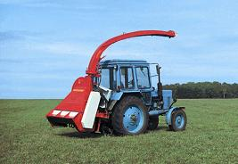Mounted mower-shredder is intended for harvesting grass, maize and other ensilage crops up to 1,2 m high with chopping and loading into the transporter-wagons.

It operates with 1,4 drawbar category tractors.

Mounted rotating mower-shredderPALESSE CH15 is certified to conformity requirements of European community with right to apply- mark.

SPECIFICATIONS

| **Characteristics** | **Measuring unit** | **Value** |
| --- | --- | --- |
| Working width | m | 1,5 |
| General output per 1 hour | t/h | 18 |
| Setting cut height, mm |  |  |
| Minimal | mm | 60 |
| Maximal | mm | 350 |
| Unloading height | m | 3,6 |
| Overall dimensions with MTZ-82 tractor in transport position |  |  |
| Length | mm | 5 300 |
| Width | mm | 2 200 |
| Height | mm | 3 500 |
| Weight | kg | 900 |

**Pull-type mower-conditioner KPP-4,2 “PALESSE CT42”**

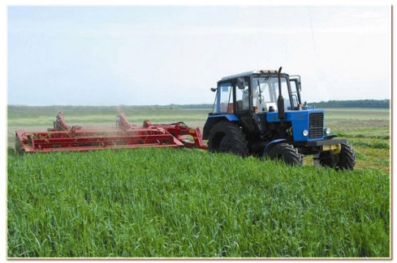Mower-conditioner KPP-4,2 “PALESSE CT42” is intended for mowing of grass with simultaneous squashing of mowed crops and putting them into swath to the stubble. Also it can be used for grass mowing without squashing with gathering of mowed mass into swath. Operates with 1,4 drawbar category tractors.

Mower-conditioner PALESSE CT42 is certified to conformity requirements of European community with right to apply -mark.

SPECIFICATIONS

|  |  |  |
| --- | --- | --- |
| **Characteristics** | **Measuring unit** | **Value** |
| Type |  | pull-type |
| Working width | m | 4,2 |
| General output per 1 hour | ha/h | 1,0…2,8 |
| Swath width | m | 0,8 ... 1,6 |
| Adjusting cutting height | mm | 50/80/130 |
| Overall dimensions in transport position |  |  |
| Length | mm | 9 100 |
| Width | mm | 3 200 |
| Height | mm | 1 760 |
| Weight | kg | 3 500 |

**Semi-coupled potato harvesting combine PKK-2-05 “PALESSE PT25”**

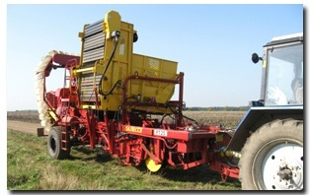

Semi-coupled potato harvesting combine PKK-2-05 “PALESSE PT25” with a bunker and a sorter desk is intended for harvesting of potato on light and medium-textured soils in moderate climate zones of potato growing, except mountainous, with the field grade limit up to 4˚.

SPECIFICATIONS

|  |  |  |
| --- | --- | --- |
| **Characteristics** | **Measuring unit** | **Value** |
| Quantity of the harvester rows | pcs | 2 |
| Inter-row spacing width | cm | 70-75/90 |
| **General output, hectares per hour** | | |
| - on the inter-row spacing 70 cm | ha/h | 0,84 |
| - on the inter-row spacing 90 cm | ha/h | 1,0 |
| Digging under depth as to the top of the ridge, up to | cm | 25 |
| Angle of ploughshares installation |  | adjustable |
| Quantity of the working places for sorters | pcs | 4 |
| Bunker volume | kg | 2 500 |
| Unloading height, up to | mm | 2 800 |
| Working speed | km/h | 2-6 |
| Transport speed | km/h | 15 |
| Vibrator of first separating conveyor |  | active |
| **Overall dimensions in transport position** | | |
| Length | mm | 10 000 |
| Width | mm | 4 000 |
| Height | mm | 4 000 |
| Weight | kg | 6 800 |