Commercial offer

«Onega» PCAL invites you to cooperate with wholesale and distribution companies, retail chains. Our company is the largest Belarusian producer of chips, snacks, seeds, nuts, instant products, bars with confectionery glaze and muesli bars.
Products are manufactured according to the following HS codes:
2005202000
1905905500
2008119800
2008199900
2005208000
1904209900
Full information on products can be obtained in our price list, as well as on our website www.onega.by.
In 2014, Onega PCAL successfully passed certification of the food safety management system for compliance with the requirements of the ISO 22000 standard, based on HACCP principles.
In December 2019 Onega PCAL passed certification according to the requirements of the FSSC 22000 scheme version 4.1. FSSC 22000 certification is recognized by the GFSI (Global Food Safety Initiative) and European Accreditation Cooperation (EA). These facts confirm the quality of the products manufactured by Onega PCAL and facilitate the supply of goods to the EU countries.
The holding includes three production sites in Minsk region (Onega PCAL, Onega Plus LLC, Snekpro LLC), which employs 350 people. The production capacity of Onega PCAL allows producing 7,278 tons of finished products per year, Onega Plus LLC - 6,120 tons of finished products per year, and Snekpro LLC - 9,828 tons of finished products per year.
Our products are widely represented in Belarus and Russia (federal and local retail). The group of companies also ships goods to the markets of Azerbaijan, Tajikistan, Uzbekistan, Ukraine, Israel, Serbia, Kazakhstan and other countries.
A wide range allows you to meet the needs of various categories of customers. Products can be shipped by rail containers and by road.
The company offers flexible terms of cooperation with an individual approach to each customer. Terms of delivery determination of the minimum and maximum lot pricing and possible discounts are determined through direct negotiations. We make products under our own brand. It takes only 90 days to develop a new product from the initial stage to the production of a batch.

With the hope of long-term fruitful cooperation

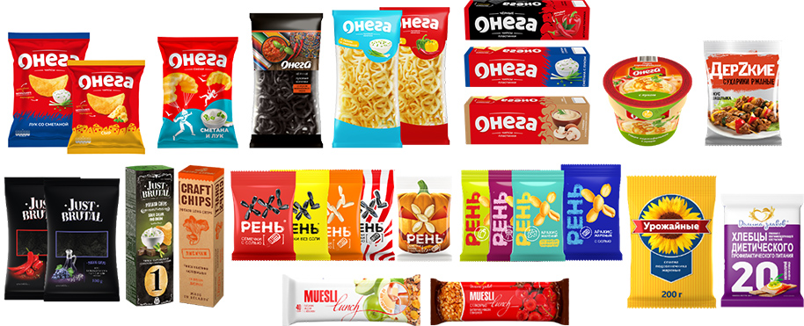

SELLER: PCAL "Onega"
223050, Republic of Belarus, Minsk Region, Minsk Area, Kolodishchansky s/s, KPP 2, room 1
Phone\fax: +375 (17) 500 53 10, 500 53 11
E-mail: info@onega.by

