Company

"SAMSONOV AND KNUDSEN”
offers

BITUMEN POWDER

consisting of oil bitumen and mineral additions containing 70-80% of bitumen.

Price: 80 USD per 1 ton
Spheres of application: road construction and repair isolation works
roofing works
production of roofing and isolation materials (roofing felt, mastics, primers, etc.)

Bitumen powder is produced by processing bitumen containing roofing waste. Since 1970-s this type of product is used in road construction and repair in USA.
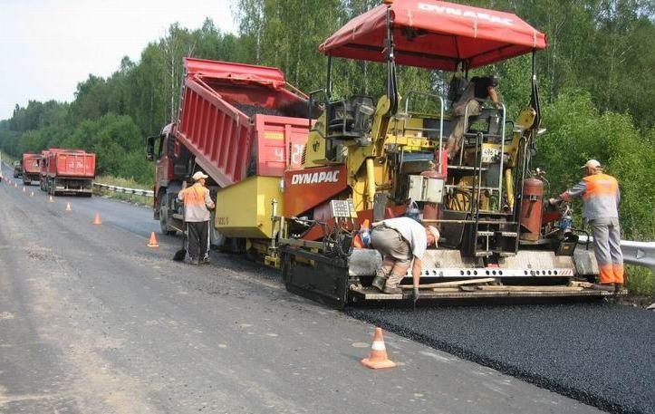It is recommended to apply up to 5% of bitumen powder out of the total mass of mix while using it for the production of asphalt mix .
When patching roads it is convenient to carry out the regeneration of the old asphalt using bitumen powder with infrared burners. In this case old asphalt is heated in mobile equipment directly at
repair site, then bitumen powder is added . After mixing
at the certain temperature the mixture is ready for patching.

Bitumen powder produced by our company is usually used in road laying,construction and maintenance, though might be used for roof, isolation works and for production of bitumen-containing materials. Using bitumen powder in road construction mixing with asphalt reduces the cost and at the same time doesn't affect the quality of the surface.
.
Pavement produced with the use of bitumen powder has a high cracking resistance, strength, plasticity, resistance to rutting, almost zero water absorption and water penetration.
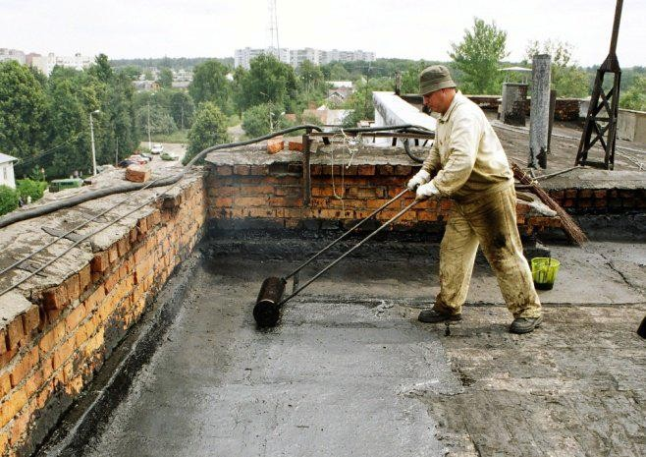For roof works bitumen powder can be used for repair of pap roofs by VIR technology or for isolation roof works.
You can produce from bitumen powder roofing and
isolation materials such as roofing material, mastic, primer.
Bitumen powder is delivered in 700-900kg big-bags by truck, railroad or sea.
We have results of our bitumen powder testing and technical regulation documentation on its application.

Save your money and natural resources using our bitumen powder!

"Samsonov and Knudsen"
legal address: 247014 Belarus, Gomel region, Bolshevik, Krasnoarmeiskaya str., 29
postal address: 247014 Belarus, Gomel region, Bolshevik, Sovetskaya str., 34, POB 11
tel./fax +375-232-94-81-38, 94-81-39
cel. +375 44 724 36 90 Alexander Orlov
email: alexincentive@yandex.ru

