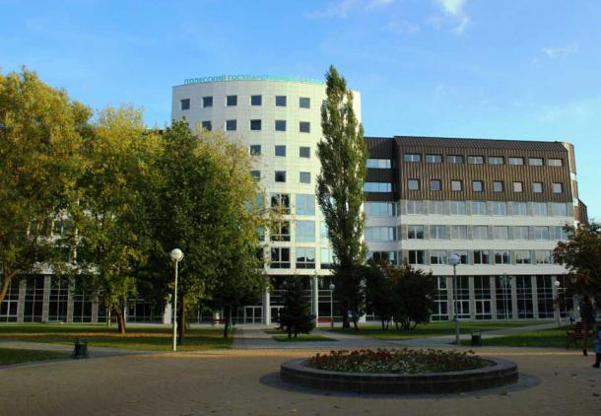
POLESSKY STATE UNIVERSITY (REPUBLIC OF BELARUS)
Tuition fee (pre-university training)
Tuition fee for foreign citizens for the pre-university program «Russian as a foreign language» comprises $1600. Payment for accommodation in a hostel, health insurance and registration fees are charged separately.
Accommodation
Foreign students are provided with a comfortable hostel for the whole period of study. Each room in the hostel has a shower and a kitchen. Payment for accommodation in the hostel comprises $ 60 per month.
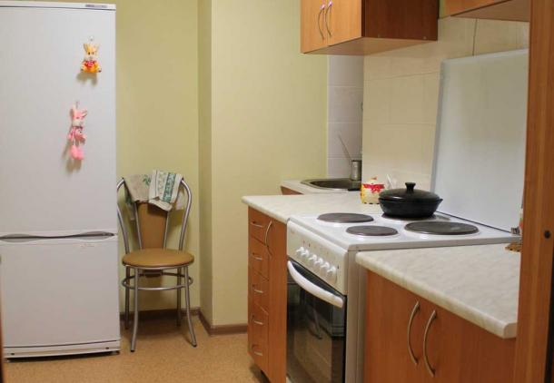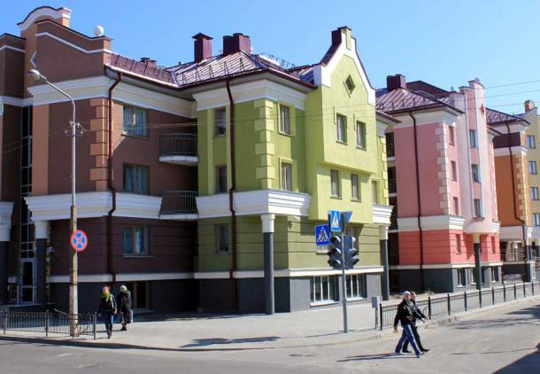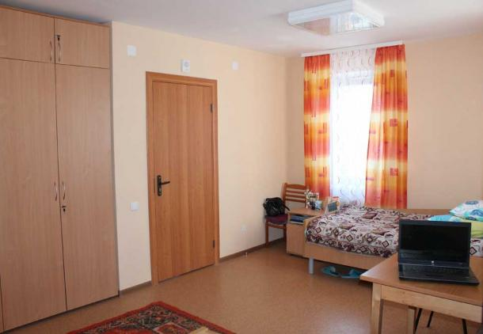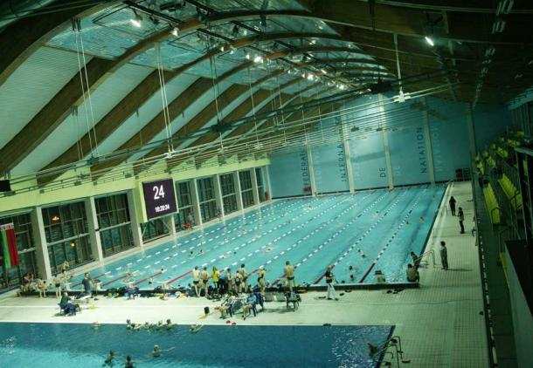
Address:
Educational Establishment “Polessky State University”
225710 Pinsk, Dneprovskoy flotilii, 23
Tel.: + 375 (165) 31 21 60
Fax: + 375 (165) 31 21 95
E-mail: box@polessu.by, vbkkoa@rambler.ru
Web-site: www.polessu.by

